Mooring Request Form

Anglian Waterways 2020-2021 Version 1.1

Please complete this form to request a mooring with the Environment Agency. We will then be in contact to confirm if any berths are available or if you are being placed on a waiting list. If a berth is available a non-refundable reservation fee may be required to secure the mooring.

Mooring Location
Northampton Marina – River Nene |  | Upware – River Great Ouse
Brigg – River Ancholme |  | Denver – River Great Ouse

Type of Mooring please see over for further details
Full Residential |  | Mixed Use |  | Leisure Use
Northampton only |  | Northampton only

Preferred Mooring Period ( minimum 4 months)
Start Date |  | End Date

Your Details |  | Preferred method  of contact
Name
Postal Address
Please note invoices will be posted to the most current address held
Postcode
Telephone
Email
Joint Owner/ Other User Name
Please state if the boat is jointly owned or anyone else, other than those named above, will be accessing or using the boat on a regular basis.

Boat Details
Name of Boat
Registration Number
Registration Authority eg CRT/EA
Please note only Environment Agency Anglian or CRT Gold registrations are valid on our waterways.
A CRT standard licence is not valid on Anglian Waterways.
Type or Class of Boat
Boat Length |  | Boat Width
Boat Safety Scheme Certificate
Number |  | Expiry date
Boat Insurance
Company
Policy number |  | Expiry Date

Please return this form to:
Post: Waterways Rented Moorings, Kingfisher House, Orton Goldhay, Peterborough, PE2 5ZR
Email: Waterways-ANRentMoor@environment-agency.gov.uk

Mooring types
Full Residential. This category allows a moorer to live aboard their boat all year. Customers pay Council Tax. We have a limited number of these moorings.
Mixed Use. Moorers are allowed to live aboard their boat for most of the year but the vessel must vacate the marina for 2 weeks in every 6 month period.
Leisure Use. This is a non-residential mooring. Customers cannot live aboard their boat and can only stay three nights out of every seven. Full details are in the terms and conditions.

Reservation Fee
This is non-refundable and will reserve a berth for 4 weeks while your agreement is being processed. Details of how to pay will be sent when a berth is confirmed as available.
Please DO NOT send any money or cheques until requested.

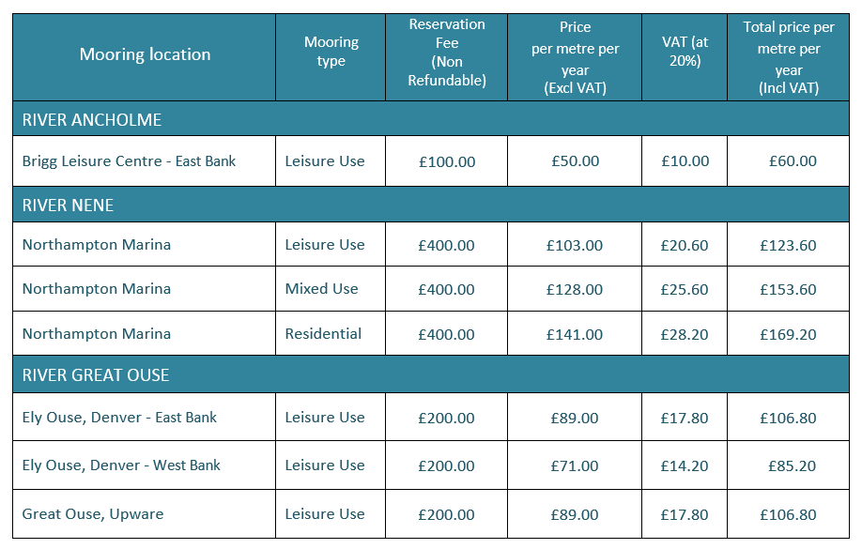
Mooring Fee Table for 2020-21

WHERE DID YOU HEAR ABOUT OUR MOORINGS?
Can you let us know how you found out about our moorings? (Please circle any that apply)
Word of mouth | Internet search | Know the area | Advertisement (where?)
Other – please give brief details

If you have any questions about this form or you need further information about a mooring please contact the Moorings Team on 0208 474 8261 or by email at Waterways-ANRentMoor@environment-agency.gov.uk

Privacy Notice
We will use your personal information for processing your mooring enquiry and mooring agreement in accordance with our Privacy Notice. Please contact us if you would like a copy of the notice.

